- Create library.xml file with the following constraints:
  - Library has book and member details
    - More than one book and member is possible
  - Books has the following elements
    - id
    - name
    - author
    - ISBN
- id, name, author are mandatory fields. More than one author and ISBN number can be possible.
  - Member has the following elements
    - id
    - password
    - name
    - age
    - email
    - phoneNumber
    - panNumber
    - passportNumber
- id, password, name, age fields are mandatory
- email is optional. maximum one email is allowed
- more than one phoneNumber is allowed.
- (passportNumber, panNumber) either this or that is allowed only once
- hightlight emailId, name and author with different color
Create the XML document for at least 10 books and 10 members. Check the XML document for well formness.
- Create a XML document with same library.xml some errors and then check the well formness.

- Write XML document for the following tree structure

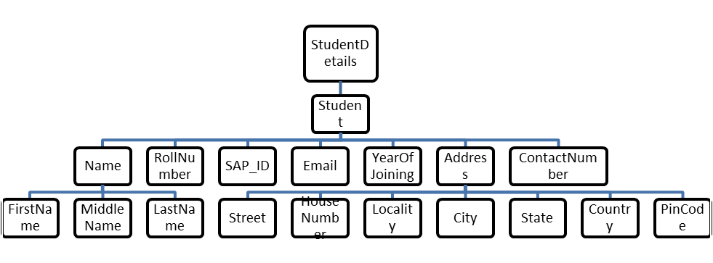
Attribute: id
Create the XML document for at least 15 students. Check the XML document for well formness.
